# | Watch for | Result | Notes / quote
1 | Both controllers stay bound: P1=Cheddar, P2=Cocoa | passed
2 | 10-sec opening explainer plays before the control card | passed
3 | Either player can skip it, and skip made sense | passed
4 | Control card readable without you explaining controls | partial | The control card dismisses itself after a period of time - I need time to look at it and accept it
5 | Game stays frozen during explainer/card |  | See above
6 | Players figure out the station order on their own |  | It’s weird that the door stare has to happen by climbing up the wall?  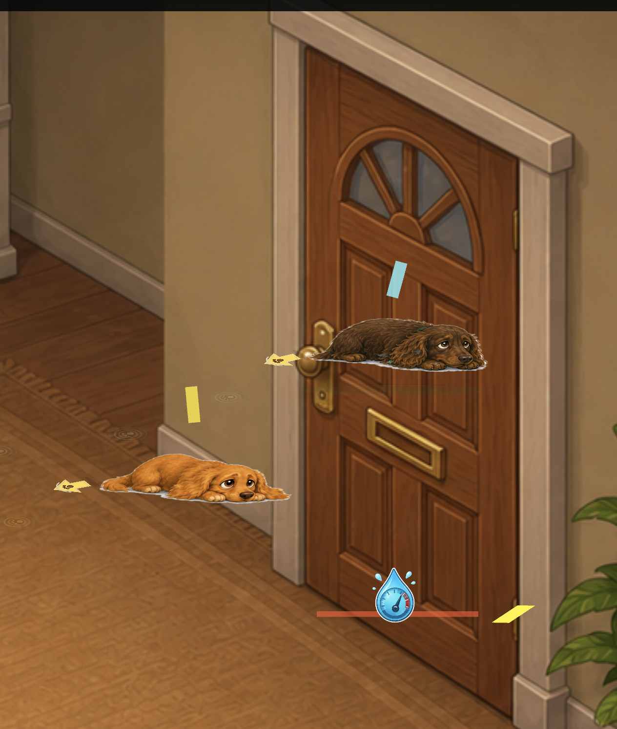
7 | No big debug circles visible (F1 off) | passed | They go away when the F1 is off
8 | Arrows, signals, labels, Teenager reactions show progress | fail | The progress meter disappears when the dogs move to bottom part of screen  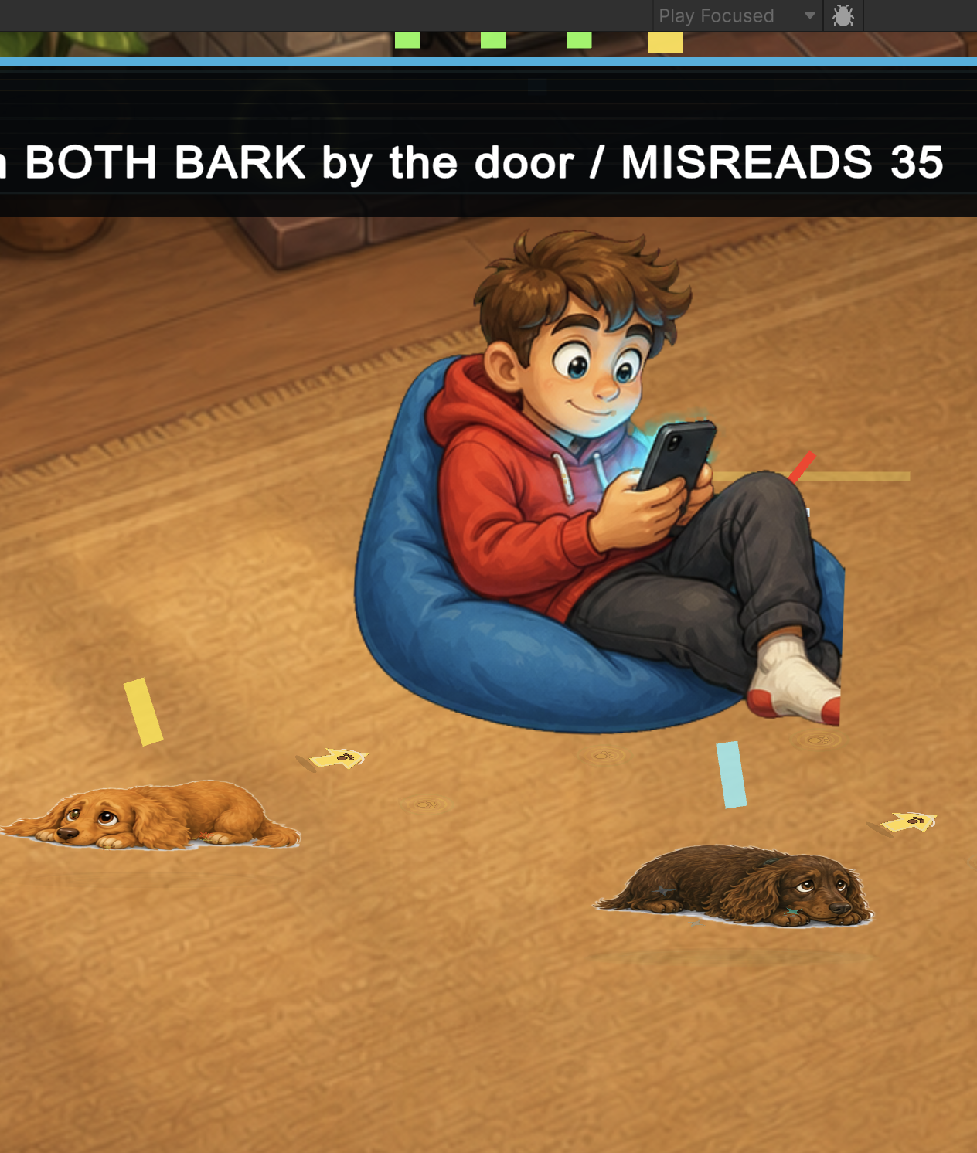  Ideally after each phase, the teenager looks a little different, or shifts positions to indicate we’re on the ‘next subproblem’
9 | BLADDER EMERGENCY reads as a meter (no numbers) | passed
10 | Toys can be batted around, don't affect the mission |  | Didn’t see this working or not…
11 | An early/wrong signal is funny + recoverable |  | Nothing really funny happens
12 | Beat 3 role flip makes sense as a two-player moment |  | Not sure what this means - but i finished the level this time
13 | Door + leash + both barks = united-bark climax |  | Pretty good - the leash needs to be animated though, maybe carried around in mouth?
14 | Open-door/hydrant payoff visible before end card | passed
15 | Success doesn't time out during the payoff hold | passed
16 | Replay resets everything (bladder, phone, toys, door) | passed

Freeform feedback:
- the title card 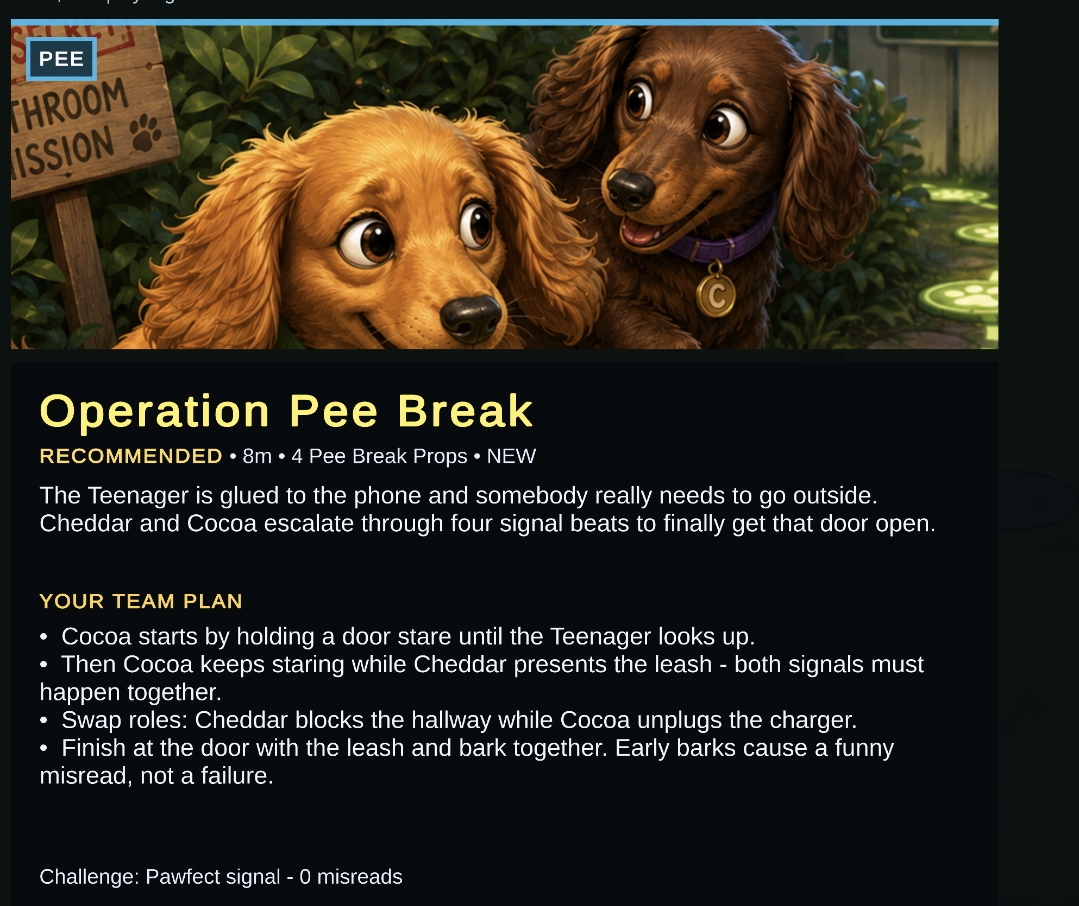
(top right) - seems to crop down most of the image, not a big deal, but detail is lost
(bottom right) - the Team plan should ideally show little visual clips of what things will actually look like on-screen if possible, just the important ones

